iCity contest

Index

- Authors
- App description
- Architecture
- User's manual
- Future development

Authors
Name: | Gerard
Surname: | Casas Saez
Email contact: | casassg@gmail.com

Name: | Oscar
Surname: | Mañas Sanchez
Email contact: | oscmansan@gmail.com

Name: | Joaquim
Surname: | Motger de la Encarnación
Email contact: | quim.motger@gmail.com

App description
App name: uSPOT
Mobile Plaftorm: requires Android 4.0 or later (API 14)
uSPOT [You-Spot] is a new whole experience. It doesn't only allow you to move around the city and find the most recommended places near to you, it also gives you the chance of sharing with everyone else your favorite spots. No matter wherever you are, uSPOT is the perfect app to find those special points you're looking for: nightlife clubs, opened parks, museums, restaurants and more. With a minimalist and an intuitive user interface, you will be able to look for the nearest places to you, check how far are they from your current location and ask for the shortest path to get there. It also gives you information about which of this spots are ready and adapted for people with mobility disabilities, so it will never become a problem for the user. However his is not all: with uSPOT you can be a part of the community itself. Share your most beloved places with everyone from your mobile phone in the same app. Make those unknown places enjoyable by everyone!
It doesn't matter if you're a tourist discovering a new place or a neighbour from the city. If you want to discover and share special places uSPOT is the tool you need. A tool for citizens, made by citizens.

Architecture
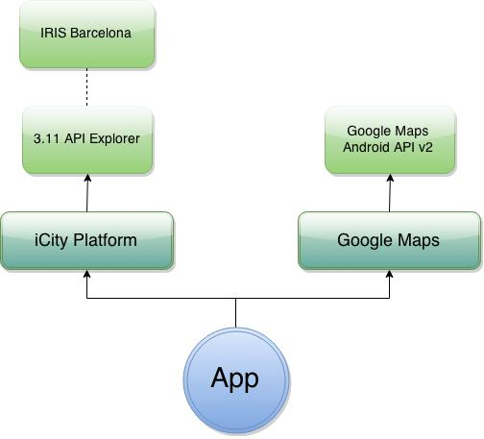
uSPOT basically depends on two APIs:
- From the iCity Platform, we use the 3.11 API Explorer, that communicates with the Barcelona IRIS infrastructure. It is used to post and get all the information of the POIs. The information provided by the API is parsed and then shown in form of cards to the user.
- From the Google Maps, we use the Google Maps Android API v2 to get the map and locate the point, in order to show it to the user.

User's manual
When initializing the app, you will see a simple interface which presents the main functionality of the app. Classified in six categories - Places, Food, Nightlife, Culture, Leisure and Shopping - the app shows in card views the different interest points the system has registered.
Looking for points of interests
You will see a top menu with the six categories, presented in tabs. You can swipe left or right to change the current category, or just click on the category you are interested in. In every section, ordered by distance and with the nearest point on the top, you can see the list of all the registered points of this category, and some information about each one - the name, the distance, and a small icon with indicates you if that place is adapted for people with mobility disabilities When you tap on a card, it will show the description about the corresponding place. Anytime you want to refresh the app, you just need to swipe down. All distances will be recalculated and the new posts will be added. The app will display the cards in the correct order.

Getting the route to a point
Every card has a small icon of a marker in the top-right corner. When clicking on it, the app will displays a map centered in the exact location of the place. By clicking on the marker of the map, you will see a new buttons on the bottom-right of the screen. One of them, will allow you to open Google Maps application and center the map on the marker. The other one will open Google Maps too, but, without any other step, it will show the directions screen to get to the interest point.
Submitting a new place
In the main screen of the app, you will see a round button on the bottom-right corner. By clicking on it, you will be taken to a new screen. In this screen you will be able to fill the necessary information to post the point of interest. Give the name, a little description and which kind of point it is. You will also be able to introduce the address or your current location, depending on your preferences. And finally, you will see a checkbox to indicate if this new place has accessibility for people with mobility disabilities. Click on the "Submit" button, refresh the app and instantly you will see your submission!

Future development
The architecture of uSPOT provides itself a great projection to be developed and expanded with many kind of new features:
- With the proper growth of the iCity infrastructures, it would be possible to make the app available in new cities. Any city that would like to have this app, they will just need to have a citizen infrastructure like IRIS Barcelona or similar.
- For a better performance, it could be useful to add a new service dedicated specifically to this use. It would be useful to the city to have a record of POIs in order to take future decisions about the city.
- With the current app architecture, it is possible to add any new kind of information available in the APIs. For example, we could add Parking information from the iCity API.

